

Motivations

* When government will start specific campaign like billion tree tsunami, any plantation campaign and clean and green Pakistan the unemployed people can get jobs by registering themselves.
* This app will automatically record the history of the volunteers who can take part in any activity and will be helpful for the future events.
* TMA officers will check the working of their employees.
* The people who want to work voluntary have a platform to work by using this app.

Background

Pakistan generates about 48.5 million tons of solid waste a year, which has been increasing more than 2 percent annually. Like other developing countries, Pakistan lacks waste management infrastructure, creating serious environmental problems. So a proper check and balance is needed on the TMA employee and aware people about this problem through a proper system.

Conclusion

We have developed android application in full working condition having expected functionalities. We have achieved our target goal. “Clean Pakistan" is responsive android application which can easily accessed by user in his/her smart phone. It was our primary goal to develop such kind of application with sufficient performance. This app can be used by Employee, Chairman and Volunteer. We have provided multiplicity in this app. So, a user can access the application anywhere and at any time. The communication is the biggest issue which is going to be solved with the android application. The people who want to become a volunteer will be able to upload their related detail in this application. TMA officials can check the performance of their worker. The user will contact with the TMA official in easy way if he see the bad condition of their street

Introduction

The “Clean Pakistan App” automate the whole system of solid waste management. It aim to facilitate the government institute like TMAs authorities to check the performance of their employees as well as the condition of solid waste in their area. The “Clean Pakistan App” is completely android based application which help the TMAs authorities, common people and volunteer and other all actors to communicate with each other for. All the actors participating in the system will have their proper account to the system through which they enter to the system via sign in/sign up and upload info according to their degree of nature. 

Future Work

Now our application is automating the solid waste by the coordination of Public and Government. In future we can further improve our android application through several ways like add Image Enhancement Techniques to improve the quality of the pictures and then we can divide the garbage into categories to improve the movement of the garbage to the dumping stations

Architecture

**Clean Pakistan App**

Final Year Project (2019-2021)

Muhammad Arshad (FA19-MCS-003) Department of Computer Science

Baqir Ali (FA19-MCS-022)

Supervised by: Miss Mehreen Wahab



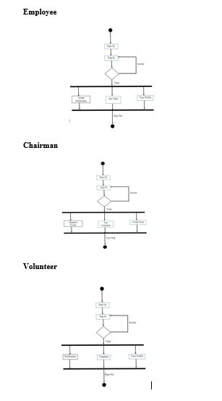

References

[1] <https://developer.android.com/about/versions/11?gclid=Cj0KCQjw7pKFBhDUARIsAFUoMDbIfp-zJh5rQ6Sx_FgNH0KbqzCX_a4PFeYqilmaT7NFYt9ZlCW8muQaAsUSEALw_wcB&gclsrc=aw.ds>

[2] <https://www.youtu.be/qK0QNA0sMGc>

[3] <https://abhiandroid.com/programming/googlemaps>

[4] <https://firebase.google.com/docs/database/android/read-and-write>

[5] <https://en.wikipedia.org/wiki/Android_software_development>

Objectives

Results

* Our main goal is to keep the environment clean.
* Manage the garbage in efficient way.
* To support the government to overcome this problem in Pakistan keep our country clean.
* Provide awareness to the Public about garbage and how to handle with them.
* This app will improve coordination between government, volunteers and public